INVESTMENT PROJECT SUMMARY/PROFILE
Construction of Technopark in FEZ “Kulob”
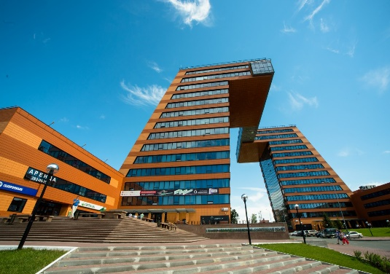 | 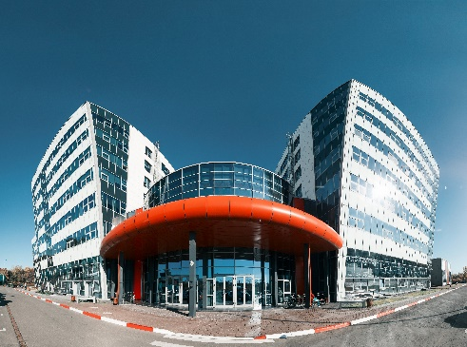 | 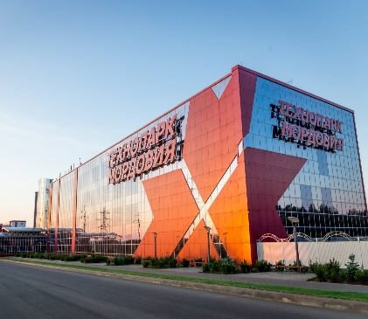
Information about project initiator
Project initiator | Administration of the free economic zone «Kulob»
Contact details | Ministry of economic development and trade Republic of Tajikistan 734001, Dushanbe city, Bokhtar street 37  Tel:(+992) 37221-34-34, 221-94-63, e-mail: info@medt.tj
Type of ownership | State enterprise/ Private property
Sector | Scientific, technological and technical base
Main idea of the project | Creation of conditions for the dynamic development of high technology through scientific, technical and technological management of the companies that make up the Technopark;  Development of potential R&D areas;  marketing of ideas, inventions and useful models and technologies;
Aim/result of project | Development and implementation of new science-intensive technologies:  Conducting complex marketing research;  Creation of new jobs.
Facilities | Engineering and laboratory buildings  - Class "A" premises  - Conference hall;  - Co-working Zone  - Dining Hall  - Computer lab
- Scientific and technological company in the field of health care, life senses and high-tech materials.
- Bureau of professional 3D printing, scanning and modeling of any complexity.
- Producers of medical supplies and materials (medical gloves, syringe, antiseptic, vaseline).
- The manufacturer of high-tech IT equipment and software.
- Manufacturer of SIM cards and bank cards
- Manufacturer of leather goods (shoes, bags)
- Cardboard box manufacturer
- Solar energy technology and engineering
- Engineering School
- Training Center for highly qualified personnel

Planned realization period (years) | 2 years
Stage of the project (business plan, project documentation, other) | A preliminary Business Plan has been developed. The project needs a feasibility study.
Project overall cost | 10 mln US$
Including | Internal funds mln. US$
 | Required investments 10 mln. US$
Profitability | 20%
Period for payback | 5 years (provided that 90-100% of residents are filled).
Type of investment | Direct investment
Investor participation form | Creation of a joint venture, the implementation of the project on the basis of an investment agreement.
Tax and custom benefits/privileges | - Enterprises registered in free economic zone are exempt from all taxes, with the exception of income tax (from employee salaries) and social tax (from payroll)  - Unobstructed export of profits  - The import of domestic and foreign goods into the territory of free economic zones is exempt from:  - Payment of customs duties  - VAT  - The export of goods from FEZ “Kulob” to other countries are exempt from:  - Payment of customs duties  - VAT  - The export of goods from FEZ “Kulob” to domestic market (Tajikistan) pay customs duties and taxes according to the legislation of the Republic of Tajikistan
Technical indicators
Location of project (or realization) | Republic of Tajikistan, Khatlon region, Kulob city, rural community of Ziraki, village of Saryozii Miyona, Free economic zone «Kulob»
Size of overall necessary production site (land) | 3.5 hectares
Area of production plants, ha | 2 hectares
Planned number of jobs | 100
Infrastructure/Communication
Power supply | There are plans to install own transformer
Water supply | There is a planned water line.
Gas supply | Not necessary.
Transport connection
Road | Connecting distance to international highway “Dushanbe- Kulob- Qalai -Khum” 14 km to FEZ «Kulob»;  Regional highway Vose- Khovaling 7 km to FEZ «Kulob»;  220 km from the Dushanbe city to FEZ «Kulob»
Airport | 1,5 km from Kulob international airport to FEZ «Kulob»
Railway | 18 km from Railway station to FEZ «Kulob»
Other

